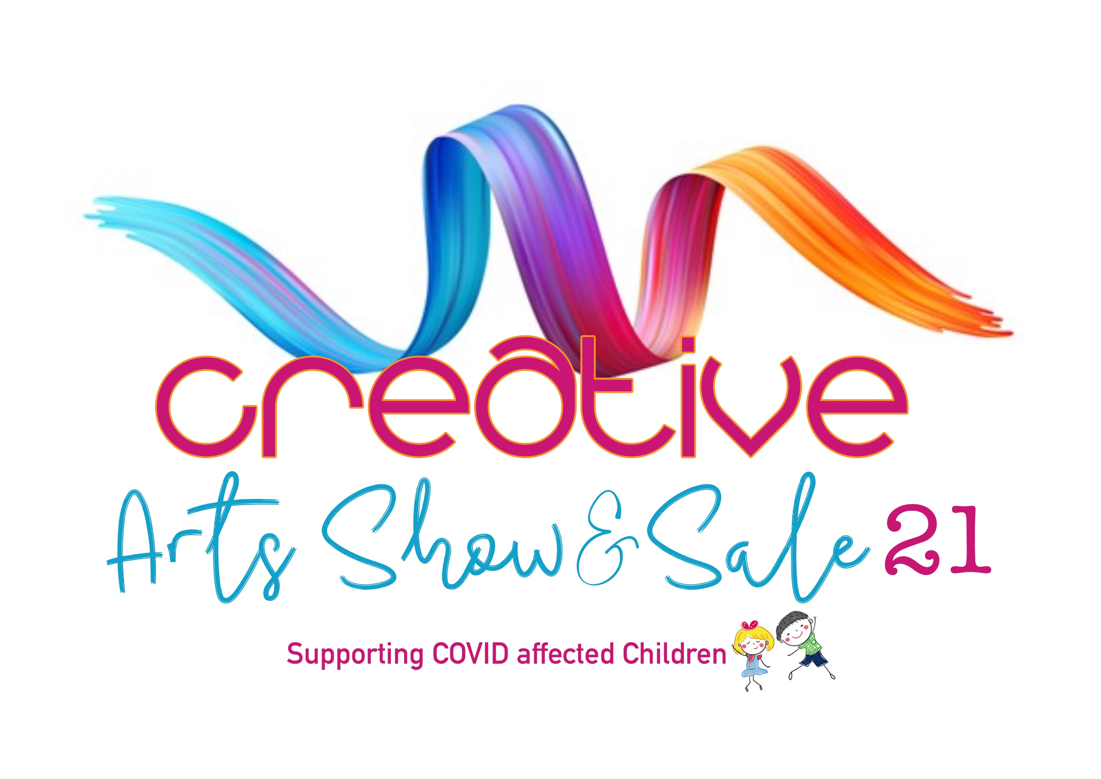
Dear Supporter,
Thank you for your interest in volunteering at our show and joining our team of Art & Craft Hero’s. The Show is to be held on 9th, 10th & 11th of July 2021 at the Bromsgrove Hotel, Birmingham Road, Bromsgrove, B61 0JB. We have a variety of roles and are looking for a committed team of people.
Please complete the following: -
- Name *
- Address *
- E-mail *
- Mobile Phone
- Emergency Contact *
- To ensure we have a spread of volunteers across the shifts, please tick as many dates and times as possible that you will be available. Apart from Thursday 8 July (which is set up day), the first ½ hour of each shift will be for briefing purposes and to allow enough time to have a handover with the volunteer on the previous shift.
Thursday July 8th 10 am – 2pm
Thursday July 8th 1pm - 4pm
Thursday July 8th 4pm - 7 pm
Friday July 9th 9.30am - 2pm
Friday July 9th 1.30pm - 4pm
Friday July 9th 3.30pm – 6.30pm
Saturday July 10th 9.30am - 2.00pm
Saturday July 10th 1.30pm - 4.00pm
Saturday July 10th 3.30pm – 6.30pm
Sunday July 11th 9.30am - 2.00pm
Sunday July 11th 1.30pm - 4.00pm
Sunday July 11th 3.30pm - 7.00pm

- Once we know volunteer numbers, we will then be able to ensure we have all rota shifts and roles covered, to assist us with this, please indicate which roles you would be interested in, we cannot guarantee which roles will be allocated: -
Entrance Desk
Visitor Information / Stewarding
Setting up/packing away
Running charity stand
Supporting stand holders
Raffle Stall
Entrance to Curated Art

- Your Special Skills (First Aid Certificate / Public Facing / Face Painting / Caricature Artist etc)
__________________________________________________________________________________
Do you have any previous experience of volunteering at an event of this type? YES / NO
- As a Thank You for your support, Volunteers will receive a £5 voucher which can be spent at any of the Stands in the Hall at the event only.
- Please submit this form as soon as possible to info@creativeartshowcase.org but no later than June 11th, 2021.
We would like to keep you informed about Creative Arts and will keep in touch by email, SMS & telephone. To opt out at any time email info@creativeartshowcase.org or telephone 07818 830988. We know your data needs to be kept safely and we never disclose it to others. For further information see our Privacy Policy, which can be found on our web site https://www.creativeartshowcase.org.
We will send you rotas, shift patterns and more details about volunteering at the event following the closing date, if you have any questions, please do not hesitate to contact me.
Thank you very much for your support of the event, it is much appreciated.
Best wishes
Dee
Dee Hirst
Return Form to: info@creativeartshowcase.org or Post to the address below

https:www.creativeartshowcase.org

CREATIVE ARTS SHOWCASE, Worms Ash Farm, Cockshutt Lane, Dodford, B61 9AT

