Creative Arts – Creative Party in the Park 2022 – CRAFT STALLS
Saturday 18th June 2022, Sanders Park, Bromsgrove

First Name Surname Prefix (if applicable) Mr/Mrs/Ms/Miss Group Name / Business Name If applicable

Mobile e-mail

Set Up/Drop off Saturday 18th June 2022 - Between 8.00 a.m. & 9.00 a.m. Closes 16.00 hours

Return form to: info@creativeartshowcase.org – a pre-payment of £20. Unsuccessful applications - down payment will be returned. Stalls charged at £20 - sizes and spaces vary – mixed size tent cover
If bringing your own tick here ☐ (size __________________________________).

Stalls offering some ‘make and take’ items to the public the whole £20 will be returned, at the end of the day.

Please indicate the content of your make and take / workshop _______________________________________________
i.e. feltwork, please enclose any promotional brochures, email your words and promotional photos for publication?)

Please indicate the sales value of your make and take workshop £_______________ i.e. free/£5/10 per person?

Bring your own table, chair and display equipment. You are responsible for your own insurance for Public Liability and value of your items. Creative Art Showcase has Public Liability Insurance for the Event. Terms & Conditions – on website

Payment details – Please make payment to :-
- Cheques to Creative Arts Showcase, Worms Ash Farm, Cockshutt Lane, Dodford, B61 9AT
- Bank Transfer direct to account - Creative Arts Showcase: - Account number 85278033 Sort Code 60-04-05 use your name/business name as a reference

Return form with pre-payment of £20 by BACs or post (address above) - or to discuss, or make suggestions about the Creative - pARTy in the Park, e-mail with your preferred contact arrangements to: - info@creativeartshowcase.org

Thank you for providing your contact details, we would like to keep you informed about Creative Arts and will keep in touch by
☐ email ☐ SMS ☐ telephone. To opt out at any time mail, info@creativeartshowcase.org or telephone 07818 830988. We know your data needs to be kept safely and we never disclose it to others. For further information see our Privacy Policy.

This year our fundraising is in aid of :- Woodland Trust, Wildlife Trust and Creative Art Showcase

Our mission is to bring Art and Creativity into the reach of all our communities promoting wellbeing & mental health.

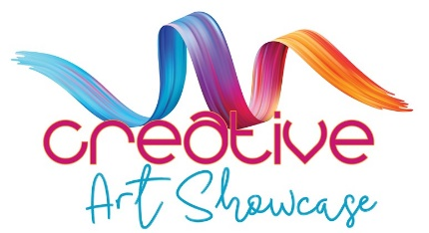

https:www.creativeartshowcase.org

Creative Art Showcase is a Registered Charity - Charities Commission for England and Wales No 1198055

