Creative Arts Showcase Festival 2022 – CRAFT WORKSHOP
Saturday October 29th & Sunday 30th | Bromsgrove School Arena & Hospitality Suite, B61 7DU

First Name Surname Prefix (if applicable) Mr/Mrs/Ms/Miss Group Name / Business Name If applicable

______________________________________________________________________________________

Mobile _____________________________ eMail ________________________________________

Set Up/Drop off: Friday 28th – 15.00-18.00 & Saturday 30th 07.30 – 9.00 hours Closes 17.00 Sat | 16.00 Sun

Return form to: info@creativeartshowcase.org – a pre-payment of £20. Unsuccessful applications - down payment will be returned. Tables costs & up to 7 chairs is included, irrespective of whether or not you use them.

Please indicate the content of your craft workshop____________________________________________________
i.e. feltwork, please enclose any promotional brochures and mail your words and promotional photos for publication?)

You can bring your own table, chair and display equipment. You are responsible for your own insurance for Public Liability and value of your items. Creative Art Showcase has Public Liability Insurance for the Event.
Terms & Conditions – on website

Please indicate the length of your workshop quantity of guests and how many we can sell per day? _____________________________(i.e. max 10) ___________________________________ (timings)
i.e. 1 hour, 20 minute clean up and next workshop every 1.5 hours Prebooked workshops will attract a commission of 10% to Creative Art Showcase, the balance will be released to you after the event.

Terms & Conditions – on website Please tick to confirm you have read and understood our T’s & C’s

Booking cost of Your Workshop Space £50 per day per 12 square feet – two tables in any shape – please sketch required shape and quantity of chairs on the bottom of this form and return as a photo or scan
- Cheques made payable to Creative Arts Showcase, Worms Ash Farm, Cockshutt Lane, Dodford, B61 9AT
- Bank Transfer direct to account - Creative Arts Showcase: - Account number 85278033 Sort Code 60-04-05

Return form with payment by email or post (address above) - or to discuss, or make suggestions about the Show e-mail with your preferred contact arrangements to: - info@creativeartshowcase.org

Thank you for providing your contact details, we would like to keep you informed about Creative Arts and will keep in touch by ☐ email ☐ SMS
☐ telephone, tick any box to opt out. To opt out at any time mail, info@creativeartshowcase.org or telephone 07818 830988. We know your data needs
to be kept safely and we never disclose it to others. For further information see our Privacy Policy.

This year our fundraising is in aid of:- Woodland Trust, Wildlife Trust and Creative Art Showcase

We bring Art and Creativity into the reach of diverse communities promoting wellbeing & mental health.

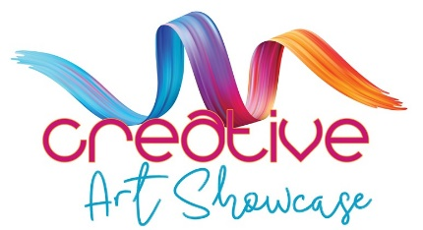

https: www.creativeartshowcase.org

Creative Art Showcase is a Registered Charity - Charities Commission for England and Wales No 1198055

