Creative Art Showcase CRAFT & ART STALLS
Saturday October 29th & Sunday 30th | Bromsgrove School Arena & Hospitality Suite, B61 7D

First Name Surname Prefix (if applicable) Mr/Mrs/Ms/Miss Group Name / Business Name If applicable

Mobile e-mail

Set Up/Drop off: Friday 28th – 15.00-18.00 & Saturday 30th 07.30 – 9.00 hours
Closes 17.00 Sat | 16.00 Sun

Return form to: info@creativeartshowcase.org – a pre-payment of £20. Unsuccessful applications - down payment will be returned. Stall charge per day (2 days minimum hire period):-
Small = one table space of 6’ £20
Medium = two table space 2 x 6’ £40
Large = three table space 3 x 6’ £60

Tables hire cost includes one chair per space irrespective of whether or not you require either.

Please indicate the content of your stall ________________________________________________________________
i.e. feltwork, please enclose any promotional brochures and mail your words and promotional photos for publication?)

You are responsible for your own insurance for Public Liability and value of your items. Creative Art Showcase has Public Liability Insurance for the Event.

Terms & Conditions – on website Please tick to confirm you have read and understood our T’s & C’s

Payment details – Please make payment to :-
- Cheques to Creative Arts Showcase, Worms Ash Farm, Cockshutt Lane, Dodford, B61 9AT
- Bank Transfer direct to account –
- Creative Arts Showcase: - Account number 85278033 Sort Code 60-04-05
- use your name/business name as a reference

Return form to info@creativeartshowcase.org with pre-payment of £20 by BACs or post (address above).

To discuss, or make suggestions about the Creative Art Showcase Event please, e-mail with your preferred contact arrangements info@creativeartshowcase.org

Thank you for providing your contact details, we would like to keep you informed about Creative Arts and will keep in touch by ☐ email ☐ SMS
☐ telephone, tick any box to opt out. To opt out at any time mail, info@creativeartshowcase.org or telephone 07818 830988. We know your data needs
to be kept safely and we never disclose it to others. For further information see our Privacy Policy.

This year our fundraising is in aid of :- Woodland Trust, Wildlife Trust and Creative Art Showcase

Our mission is to bring Art and Creativity into the reach of all our communities promoting wellbeing & mental health.

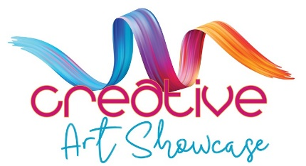

https:www.creativeartshowcase.org
Creative Art Showcase is a Registered Charity - Charities Commission for England and Wales No 1198055

