Mixed Artists Sale Form

Saturday October 29th & Sunday 30th Bromsgrove School Arena & Hospitality Suite, B61 7DU

First Name Surname Business Name If Applicable

Contact details- Email &Tel

Description of goods overleaf.

If you would like to donate a % of your profits to charity indicate here - %
Minimum of 10% is necessary

Your Bank details-

A/C Name Account Number Sort code (*Payment will be made to you within one working week)

Drop off your goods for sale –
Friday 28th - Between 14.00 – 18.00pm (Bromsgrove School) YES/NO

Contact us on 07818 830988 to leave artwork at an earlier date. at *Worms Ash Farm, Cockshutt Lane, Dodford, B61 9AT) YES/NO

Collection- Sunday 11th from 17.00-at the School Phone for alternative arrangement
YES/NO YES/NO
Where no collection arrangements are in place CAS reserve the right to sell left over goods for Charity or donate to another Charity to use.

Discount- Do you want us to discount your items by 20% at 14.00 on the Sunday? YES/NO

Please submit this form via e-mail to info@creativeartshowcase.org or via post to Creative Arts Showcase * OR just arrive with form completed, & items labelled, on Thursday 8th.

Attached pictures of artwork is welcomed, but not essential. Please note whilst every care will be taken with the goods left with us for sale, but they are not covered by our Public Liability Insurance.

Office use only- Code name-
Repayment made to Artist Date and initial
Thank you for your interest in Creative Arts & Crafts Show & Sale 21:- we are passionate about showcasing your talent and bringing 'hands on' appreciation' to our extended community whilst supporting children post Covid.

Mixed Artist Sale Form

Please comment the name and description of all goods that are being submitted here *Please tag all goods securely with your name, price, and item No to match this list.

Item  No  Office use | Name- of product | Description -of product | £ -you want it to be sold at | Sold  Office use only
 | Total Sales
If you are submitting further items - copy and paste this sheet for more columns

Our mission is to bring Art and Creativity into the reach of all our communities promoting wellbeing & mental health.

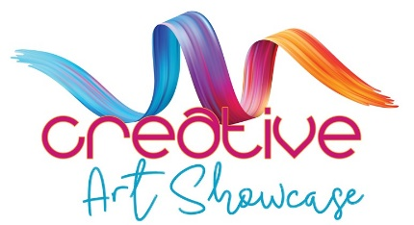

https:www.creativeartshowcase.org

Creative Art Showcase is a Registered Charity - Charities Commission for England and Wales No 1198055

