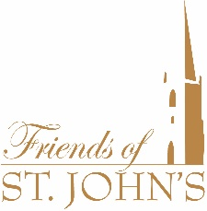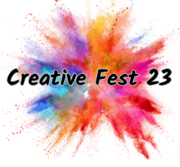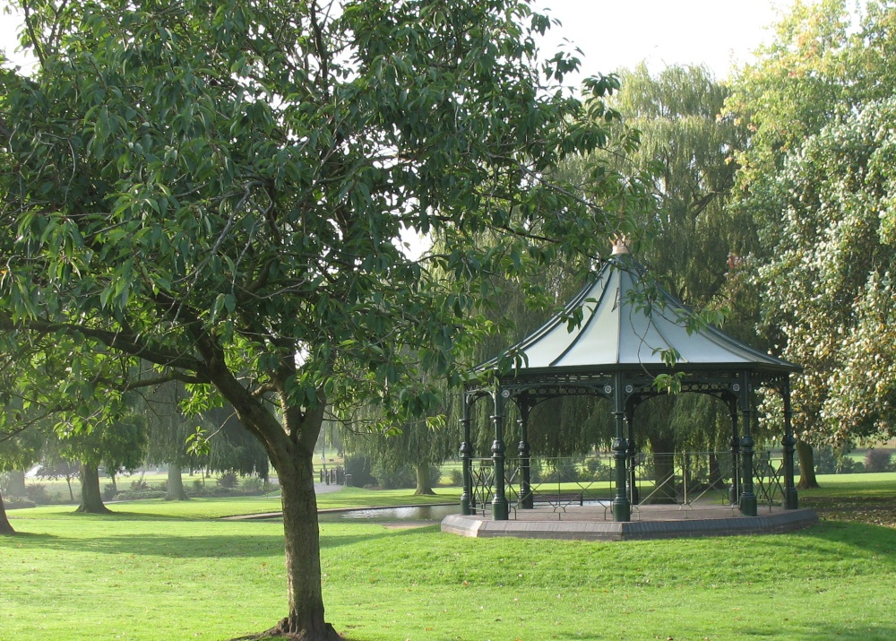

**Creative Fest 23 Photo Competition**

For more information and competition rules.

**#creativefestphoto**

****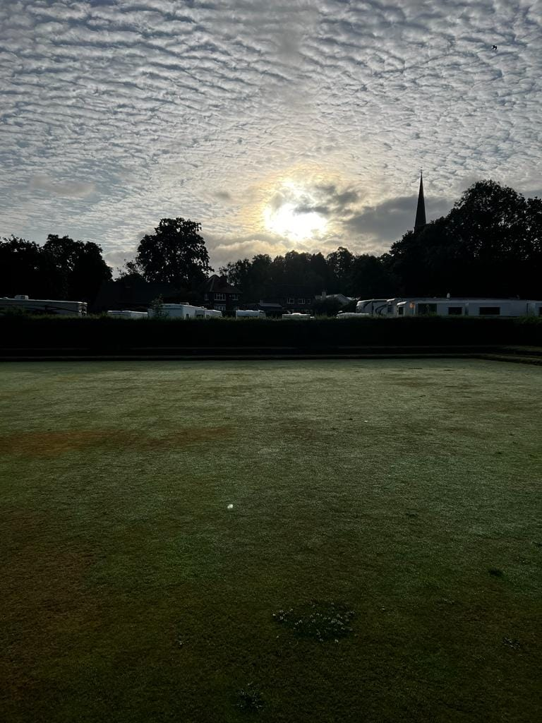

Creative Fest 23 Photo Competition

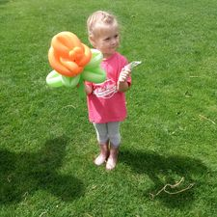

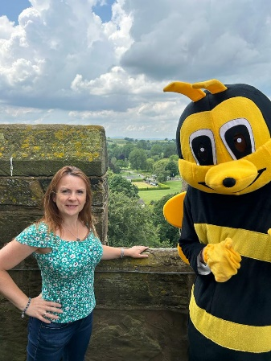**

**Welcome to Creative Fest 23 & Friends of St John’s Photo Competition!**

**“A picture paints a thousand words” and we want to see yours.**

**Creative Fest 23 promises to be colourful, arty and fun. In collaboration with Friends of St John’s Church we are looking for an image that captures the very essence of 22nd July - Creative Fest 23 and St John’s Open Day.**

**Judged by 3 Bromsgrove Photographic Society members - they will be looking at your maximum 3 entries, which need to be submitted to** [**creativefest_photos@yahoo.com**](mailto:creativefest_photos@yahoo.com) **no later than 5th August 2023. Each photo must be taken by the entrant and accompanied with a catchy title. If sending pictures of people please ensure you have their permission first.**

**First prize is £50! Second and third are £25 each and winners will be announced on social media.**

**Any questions and for T&Cs please see website or email info@CreativeArtShowcase.org**

**#creativefestphoto**